ADDRESS | AMOUNT | AVAILABILITY | VIEW | ADDITIONAL INFORMATION
PASSAIC COUNTY
3rd St #S13  Passaic, NJ 07055 | $1,350/mo | NOW | 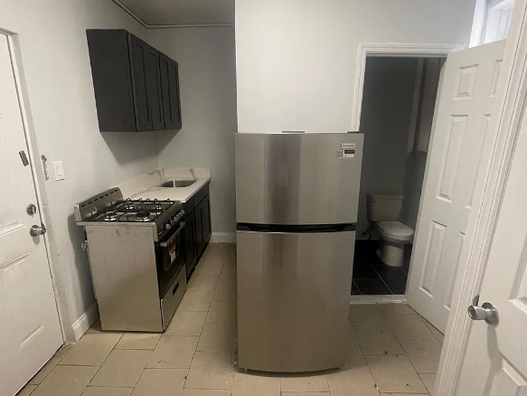 | Leasing  (973) 559-2776  New doors, new floors, new appliances  1 Bedroom Apartment FOR RENT!! $1,350  New floors, new doors, new appliances, freshly painted.  To be rented to only one family or single people.  1 1/2 deposit. No realtor fees  Owner pays water and heat. Tenant pays for electric and gas. No smoking allowed. Small pets allowed  Bedrooms & bathrooms  - Bedrooms: 1  - Bathrooms: 1  - Full bathrooms: 1  Appliances  - Laundry: Contact manager  Property  Parking  - Details: Contact manager  Features  - Exterior features: Electricity not included in rent, Gas not included in rent
282 Ellison St #5, Paterson, NJ 07501 | $1,550/mo | NOW | 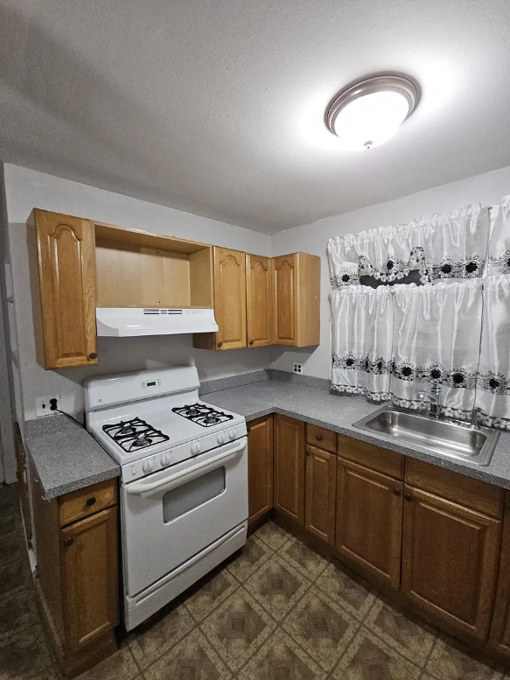 | Zebra Management  (201) 266-3331  Costs & fees breakdown  Apartment  Available Now  Cats, small dogs OK  -- A/C  None laundry  -- Parking  -- Heating  Contact manager for more details about this home.  What's special  Sleek modern apartment Brand-new appliances Upscale yet welcoming environment Refined living space  Elegantly Revitalized Residence with Modern Touches  Discover a beautifully updated home featuring brand-new appliances and a prime location within a vibrant, sought-after neighborhood. Enjoy the convenience of nearby public transit and an array of local amenities just a stroll away.  Stylish and Thoughtfully Renovated Living  Experience the charm of a sleek, modern apartment designed with your comfort in mind. Perfectly situated near shops, picturesque parks, efficient transit options, and more, this residence offers unparalleled convenience.  Contemporary Comfort for Your Family  Step into a refined living space tailored for you and your family. Every detail has been carefully curated to create an upscale yet welcoming environment that truly feels like home.  Exceptional Management You Can Trust  Rest assured knowing your new apartment is managed by a dedicated team committed to delivering a seamless living experience. With responsive, around-the-clock support, you can enjoy peace of mind every day.  Elevate your lifestyle and embrace this exceptional opportunity.  Please note: A $50 non-refundable application fee applies.
159 12th Ave, Paterson, NJ 07501 | $1,309/mo | NOW | 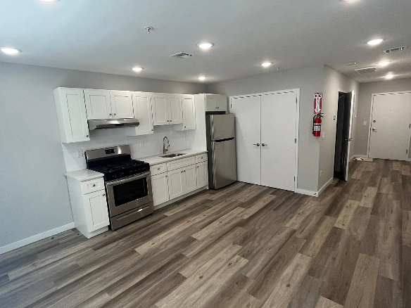 | Bedrooms & bathrooms  Bedrooms: 0  Bathrooms: 1  Full bathrooms: 1  Heating  Forced Air  Cooling  Central Air  Appliances  Laundry: Hookups  Features  WD Hookup  Flooring: Hardwood  Interior area  Total interior livable area: 430 sqft  Property  Parking  Parking features: Attached  Has attached garage: Yes  Details: Contact manager  Features  Exterior features: Heating system: Forced Air  Construction  Type & style  Home type: Apartment  Property subtype: Apartment  Building  Management  Pets allowed: Yes
60-62 Dayton Ave #10, Passaic, NJ 07055 | $1,600/mo | NOW | 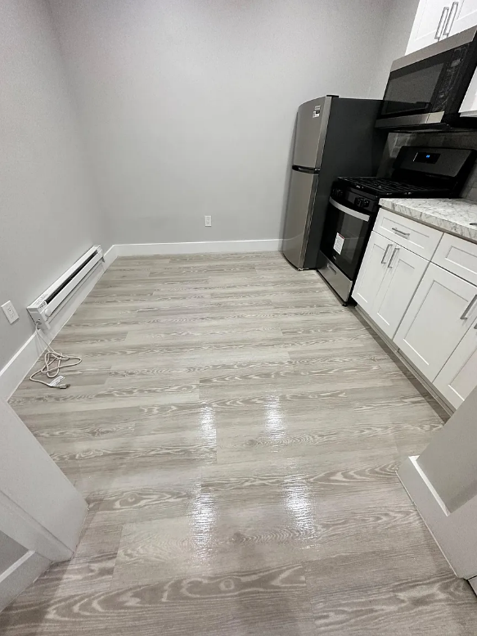 | Alain Spira  Bonim Realty LLC  (646) 328-6224  Apartment  Available --- --  No pets  Window unit  None laundry  Off street parking  Baseboard  Contact manager for more details about this home.  Cozy space  This brand-new, 1-bedroom apartment is the perfect blend of comfort and modern living. Located in a vibrant community, this cozy space is designed with your convenience in mind. Brand New Construction: Be the first to experience the freshness of a recently constructed apartment. Everything is pristine and ready for you to make it your own.  Owner pays for hot and cold water. Renter pays for gas and electric. No smoking allowed.
Freedom Village Senior 55+  69 Straight St, Paterson, NJ 07501 | $1,398 - $1,405 | Waiting List | 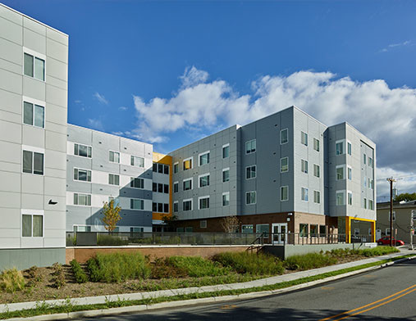 | (862) 281-6244  Apply today to join our waitlist! At Freedom Village, you’ll find a brand new 55+ and 62+ senior apartments in Paterson, NJ, designed with your active lifestyle in mind. Please visit FreedomVillageNJ.com for more information and the pre-application. This fully gated community just steps from convenient public transportation will allow you to live the active, exciting life you desire! In each one-bedroom apartment, you’ll find an open design and large windows that make coming home something special. Adding to these wonderful comforts, you’ll also enjoy all of the extras at Freedom Village such as our community room, on-site fitness center and a variety of resident services. This is the kind of home you’ve been looking for. At Freedom Village, we bring it all together. Applicants for the subsidized units at Freedom Village must be referred by the Paterson Housing Authority.  Freedom Village Senior 55+ is an apartment community located in Passaic County and the 07501 ZIP Code. This area is served by the Paterson Public attendance zone.  Unique Features  Ceramic-Tiled Baths  Community Kitchenette  Individually Controlled Cooling  Individually Controlled Heating  Senior Community  24-Hour Emergency Call Service  Oversized Windows  Healthcare Suite  Open Floor Plans
1590 Union Valley Rd #1600B, West Milford, NJ 07480 | $1,499/mo | NOW | 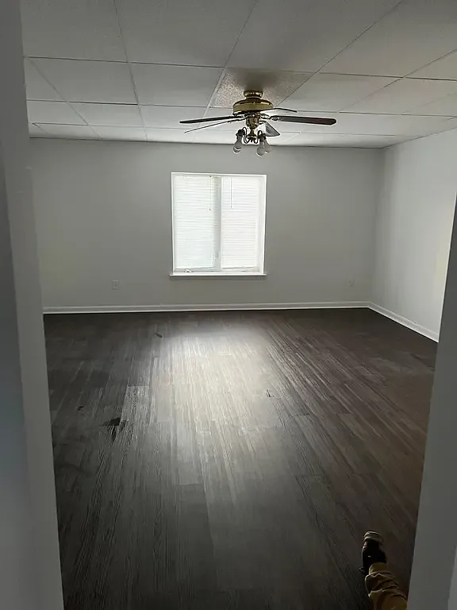 | BSG Management Company  (201) 380-9200  Apartment  Available Now  No pets  -- A/C  None laundry  Off street parking  -- Heating  Interior  Bedrooms & bathrooms  Bedrooms: 1  Bathrooms: 1  Full bathrooms: 1  Appliances  Laundry: Contact manager  Features  Flooring: Hardwood  Interior area  Total interior livable area: 800 sqft  Property  Parking  Parking features: Off Street  Details: Contact manager  Features  Exterior features: Sewage included in rent, Water included in rent  Construction  Type & style  Home type: Apartment  Property subtype: Apartment  Utilities & green energy  Utilities for property: Sewage, Water  Building  Management  Pets allowed: No  Location  Region: West Milford  Financial & listing details  Lease term: 1 Year
ESSEX COUNTY
The Pioneer  15 Summit St, East Orange, NJ 07017 | 307: Unit 307  $1,495 / mo | NOW | 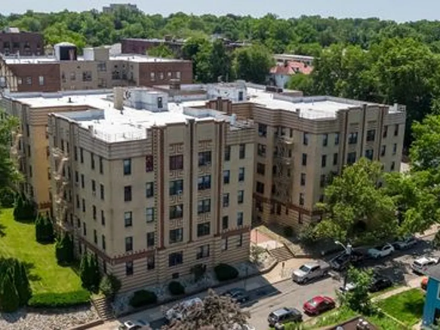 | (973) 737-9606  Leasing Agent  Benjamin H. Realty Corp.  Unit description  The Pioneer in East Orange, NJ along with TheOaks at 15 Summit St are two properties in our portfolio located on this tree-lined, neighborhood street. Both properties are conveniently situated between the Main Street shopping district and Park Avenue providing extremely easy access to the neighboring communities of Orange, West Orange, Bloomfield and Newark . Both of these Benjamin H. Realty Corp. properties feature large floor plans designed to maximize available space. The Pioneer offers recently renovated one, two and hard to find three bedroom bedroom units with heat & hot water included , plus on-site parking and laundry facilities. The exterior of The Pioneer is maintained with professional landscaping to help the building's visual appeal. The Pioneer offers families a great location with a short walk to the highly regarded East Orange YMCA located at 100 North Arlington Ave which has something for everyone. For essential healthcare workers, these large units provide an ideal location for roommates working at East Orange General Hospital which is a short walk. The East Orange VA Medical Center, Clara Maass Medical Center, University Hospital and Columbus Hospital are all only a short ride away, For faculty and graduate students looking for off campus housing, both of the properties on Summit St as well as a the collection of North Arlington Avenue properties provide convenient access to the Newark Campuses of Rutgers, NJIT and Seton Hall Law School as well as nearby Seton Hall University, Bloomfield College and Montclair State University. City Hall and The East Orange Train Station are just a short walk. Contact Benjamin H. Realty Corp. today for more information about this location and others in our portfolio located throughout East Orange and Orange, New Jersey.  Lease terms  Lease length: Contact property manager for details  Deposit and fees: $2,243  Contact property  Costs & fees  Select a unit-type to view your estimated move-in costs.  1 bed  Est. monthly cost$1,495  Est. one-time cost$2,242.5  Est. move-in cost$3,737.5
The Regency  36 S Munn Ave, East Orange, NJ 07018 | $1,550+ | NOW | 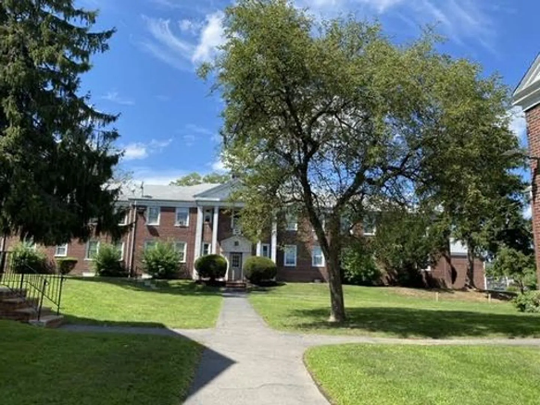 | Benjamin H. Realty Corp.  Management company  (973) 672-1020  First month's base rent  $1,550+  Security deposit  $2,325  Administration fee  Contact  Contact property for amount  Application fee  Contact  Contact property for amount  Optional  Pet deposit  Contact  Contact property for amount  Estimated total  $3,875+  Due monthly  Required  Monthly base rent  $1,550+  Pricing is subject to change. All calculations are estimates and provided for informational purposes only. Actual amounts may include additional mandatory or optional fees. Please consult the community manager for a complete breakdown of all rental costs.  Unit amenities  Features may not be available for all units  Refrigerator  Range/oven  Rangeoven  Unit description  The Regency -  Lease terms  Lease length: Contact property manager for details  Deposit and fees: $2,325
Essence 144  144 S Harrison St, East Orange, NJ 07018 | $1,600+  Studio  $1,800+  1 bd | NOW | 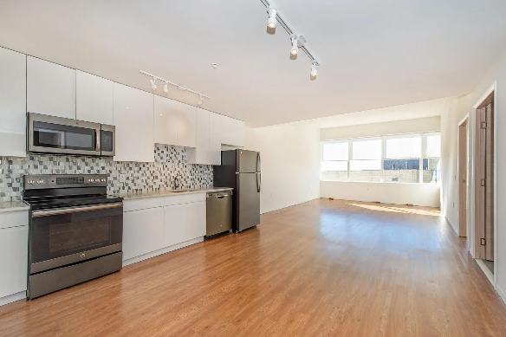 | Leasing Agent  Blackstone Realty  Management company  (862) 314-6197  In-unit laundry  Fresh sheets when you want them  This building features in-unit laundry. Only 18% of buildings in East Orange have this amenity.  In-unit washer and dryerVinyl flooringFlooded with natural sunlightPorcelain tileFloor to ceiling windowsHigh-end finishesStainless steel appliances  Modern & spacious studio, 1, and 2BR apartments with open floor layouts, floor to ceiling windows flooded with natural sunlight, and high-end finishes. Each apartment is equipped with an in-unit washer & dryer, and stainless steel appliances including a refrigerator, microwave, and dishwasher. The entire apartment is laid in vinyl flooring, and porcelain tile throughout the kitchen backsplash and bathroom. Essence 144 is a 13-story high-rise residence where modern lofts, luxe amenities, and an ideal location converge for elevated, contemporary living. Beyond essentials such as onsite parking, concierge, and an in-unit washer and dryer. Essence 144 features a rooftop lounge, fitness center, and resident lounge. To top it all off, our high-rise residence is located just 12 miles from NYC, with an express train to NY Penn Station accessible within a short walk from the residence.  Hide  Facts, features & policies  Building amenities  Community rooms  Fitness center  Library  Lounge  Party room  Outdoor common areas  Rooftop deck  Security  Doorman  Services & facilities  Elevator  Online maintenance portal  Online rent payment  Package service  View description  City  Policies  Lease terms  One year  Parking  Surface Parking Lot  $125 per month  Detached garage  Parking lot  Covered parking  Pets  Large dogs  Not allowed  Small dogs  Allowed  Cats  Allowed  Utilities included in rent  Garbage  Sewer  Water  Unit features  Appliances  Dishwasher  Dryer  Freezer  Microwave oven  Oven  Range  Refrigerator  Washer  Cooling  Air conditioning  Flooring  Hardwood  Laminate  Tile  Vinyl  Heating  Electric  Internet/Satellite  High-speed internet  Other  Patio or Balcony  Special features  Pet friendly
The Alpine  17 Shepard Ave, East Orange, NJ 07018 | $1,575  The Alpine  1+  beds,  1+  baths | NOW | 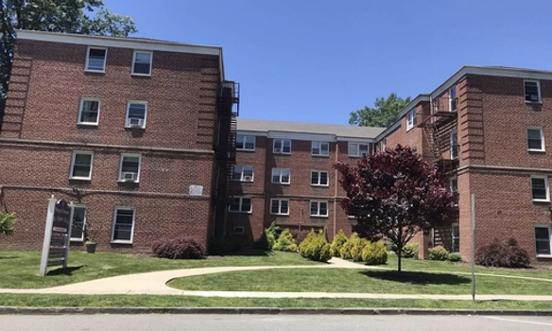 | Benjamin H. Realty Corp.  Management company  (973) 672-1020  Newly-tiled kitchens and bathrooms  The Alpine apartment building at 17 Shepard Circle along with properties in our portfolio located on So. Arlington Ave and Lenox Ave provide an ideal location for residents looking to live close to local government and municipal services. City Hall is a short 5 minutes walk and steps away from the East Orange Public Library, the East Orange General Hospital, the East Orange Police Department and the East Orange Municipal Court. If you work for the City of East Orange or at the Hospital, your commute couldn't be any shorter. Offering one bedroom and two bedroom apartments , The Alpine is a suitable new home for individuals wanting space for a home office, students and staff at local universities as well as those looking to start a family and relocating to the area. East Orange is a lively community with plentiful resources for shopping and dining both in town and nearby South Orange for The Alpine residents.  The building has been renovated over the years to show off its best features to both residents and guests. Newly-tiled kitchens and bathrooms will ensure cleaner homes and more dazzling appearances for every resident of The Alpine. The property is equipped with access control to improve security and includes laundry facilities as well as off-street parking. Our location is just one block away from the East Orange Train Station providing access to NJ Transit's Morris-Essex line for those needing public transportation to commute east or west. Commuting by car is a breeze with almost immediate access to Route 280 and the Garden State Parkway.  To find out more about New Jersey apartments in this popular and affordable building, you can visit The Alpine in person or contact a Benjamin H. Realty Corp.  Hide  Facts, features & policies  Policies  Utilities included in rent  Hot water  Unit features  Appliances  Refrigerator  Special features  RangeOven
30 Lenox Ave  30 Lenox Ave, East Orange, NJ 07018 | $1,500 | NOW | 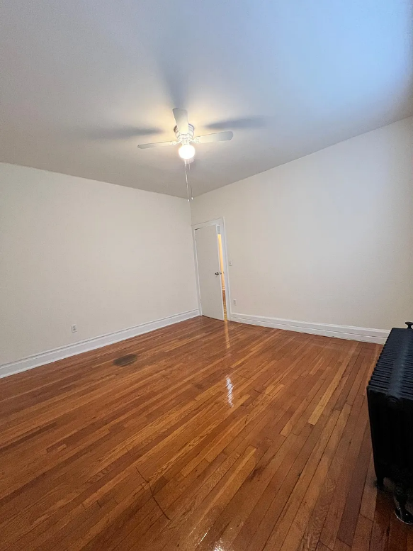 | Leasing Agent  Management  Management company  (551) 291-2826  Spanish spoken here  Some of the staff speak Spanish  This building features Spanish speaking staff. Only 7% of buildings in East Orange offer this.  If your looking for comfort, quiet, and the most convenient location, look no further. This lovely property is nestled just minutes from the public library, city parks, and around the corner from both East Orange Train Station and the entrances to Rt 280 and Garden State Parkway. Our on-site management is responsive and capable and we do our best to provide top tier service to our clients in a timely and considerate manor. If your looking for a peaceful community feel, look no further.  Office hours  Day Open Hours  Mon - Fri: By appointment only  Sat: By appointment only  Sun: By appointment only  Facts, features & policies  Building amenities  Security  Intercom  Services & facilities  24 hour maintenance  Elevator  Online maintenance portal  Online rent payment  Onsite management  Shared laundry  Spanish-speaking staff  View description  Park  Policies  Lease terms  One year  Parking  Parking lot  Pets  Large dogs  Not allowed  Cats  Not allowed  Small dogs  Not allowed  Utilities included in rent  Heat  Unit features  Appliances  Oven  Range  Refrigerator  Cooling  Air conditioning: Window  Ceiling fan  Flooring  Hardwood  Tile  Special features  Ample Closet Space  Flooring: Marble  Stainless Appliances  Steps from local park
Brookdale Apartments  95 Tracy Pl, Hackensack, NJ 07601 | $1,750+ | NOW | 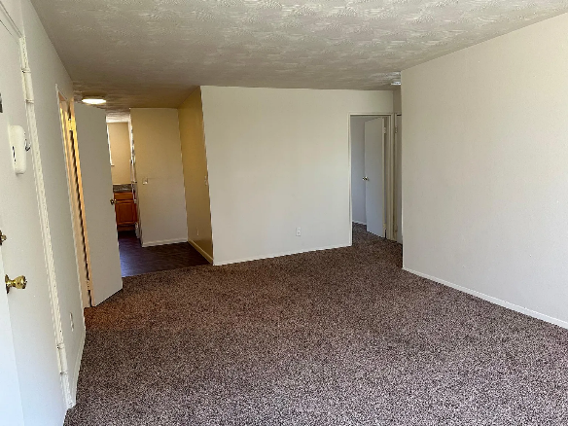 | Reiko Kondo  Management company  (551) 266-5248  Hardwood floor  Brookdale Apartments in Hackensack isn't just a place to live it's a place to call home. We invite you to be part of our community, where every day feels like a breath of fresh air. You must have 675+ credit score and 3 times rent verifiable income to be qualified. No co-signers and/or guarantors accepted. Contact us today to schedule your visit and experience the perfect blend of peaceful living and modern convenience. 1st month rent, 1 month security deposit and 1 month broker fee required to move in. Unit 139C is on the 2nd floor, hardwood floor and ready to move in.  Office hours  Day Open Hours  Mon - Fri: 9 am - 5 pm  Sat: Closed  Sun: Closed  Facts, features & policies  Building amenities  Services & facilities  24 hour maintenance  Online rent payment  Shared laundry  Policies  Lease terms  One year  Parking  Parking lot  Pets  Large dogs  Not allowed  Cats  Allowed  1 pet max  Small dogs  Not allowed  Utilities included in rent  Water  Heat  Hot water  Unit features  Appliances  Range  Refrigerator  Cooling  Air conditioning: Wall  Flooring  Carpet  Hardwood  Heating  Gas
Cambridge Arms  100 Polifly Rd, Hackensack, NJ 07601 | $1,495 - $1,695 | NOW | 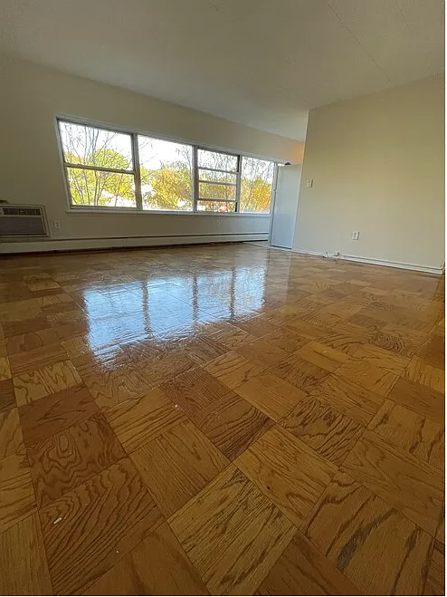 | Leasing Agent  JP Management  Management company  (201) 419-6910  Spanish spoken here  Some of the staff speak Spanish  This building features Spanish speaking staff. Only 14% of buildings in Hackensack offer this.  Spacious apartments  Cambridge Arms Apartments is a mid-rise building situated just minutes from the heart of Hackensack. We currently have a studio & one bedroom available. These spacious apartments includes gas heat & hot water! Tenant only pays for electric. Laundry facility available on every floor. Garages available. Rental price for 1 bedroom & 2 bedrooms includes 1 parking spot.  Close to shopping and dining. Building is steps away from the bus stop. Great location for commuters with transportation to Newark Penn Station and NYC Port Authority. (76 & 144) - Very close to major highways, including Route 80,17,46.  Pet friendly!  **NO BROKER FEE**  Show more  Office hours  Day Open Hours  Mon - Fri: 8 am - 5 pm  Sat: By appointment only  Sun: Closed  Facts, features & policies  Building amenities  Security  Intercom  Services & facilities  24 hour maintenance  Elevator  Online rent payment  Shared laundry  Spanish-speaking staff  View description  City  Policies  Lease terms  One year  Parking  One parking spot in lot included with apartment  Parking lot  Pets  Large dogs  Allowed  Small dogs  Allowed  Cats  Allowed  Utilities included in rent  Garbage  Gas  Sewer  Water  Heat  Hot water  Unit features  Appliances  Dishwasher  Microwave oven  Oven  Range  Refrigerator  Cooling  Air conditioning  Flooring  Hardwood  Heating  Gas  Internet/Satellite  Cable  High-speed internet  Special features  Amazon Hub Apartment Locker  Garage
Sheridan Gardens  1093 Sheridan Ave, Elizabeth, NJ 07208 | $1,550+ | NOW | 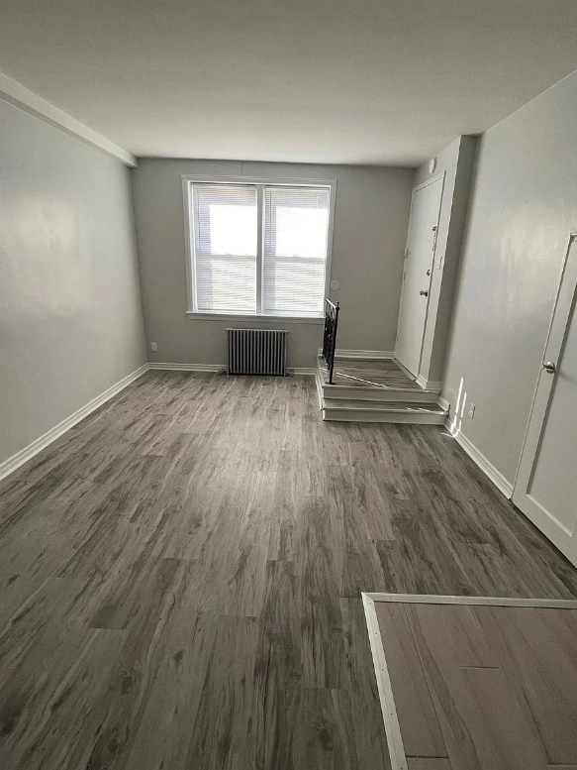 | Property Manager Maria  Management company  (908) 356-4132  WE CURRENTLY HAVE APARTMENTS AVAILABLE. FIRST COME FIRST SERVE. APPOINTMENT IS NEEDED. REQUIRED NET INCOME LISTED BELOW, AND CREDIT MUST BE AT LEAST 650, MUST HAVE RENTAL HISTORY AND APPLICATION FEE IS $50 (NON-REFUNDABLE)  Studios - $1250 - INCOME NEEDS TO BE $3125 OR MORE- 4 AVAILABLE  1 bedrooms- $1550 - INCOME NEEDS TO BE $3875 OR MORE- 8 AVAILABLE  4 bedroom- $2150 -2 AVAILABLE  Heat, hot water and one parking space included. (Garages available at additional cost of $150 per month. Currently have only 1 available  Office hours  Day Open Hours  Mon: 9 am - 1 pm  Tue: 2 pm - 4:30 pm  Wed: 9 am - 1 pm  Thu: 2 pm - 4:30 pm  Fri: 9 am - 1 pm  Sat: Closed  Sun: Closed  Facts, features & policies  Building amenities  Services & facilities  24 hour maintenance  Online rent payment  Onsite management  Policies  Lease terms  One year  Parking  Parking lot  Pets  Large dogs  Not allowed  Cats  Not allowed  Small dogs  Not allowed  Utilities included in rent  Heat  Hot water  Unit features  Appliances  Freezer  Oven  Range  Refrigerator  Flooring  Hardwood  Laminate  Tile  Heating  Gas
1011 E Jersey St, Elizabeth, NJ 07201 | $1,595 | NOW | 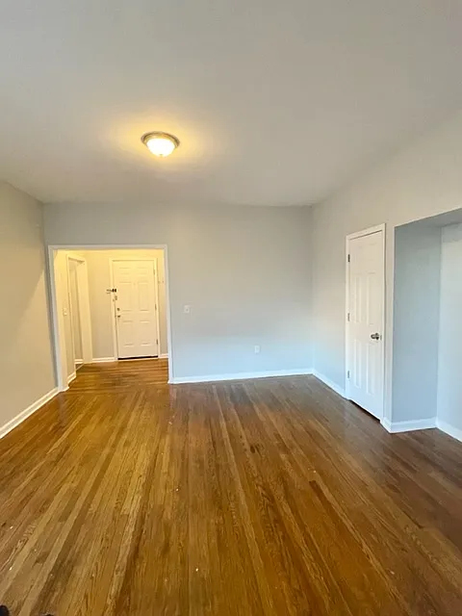 | Off street parking  Renovated kitchens  Hardwood flooring  Large Layout 1-2 BR units on East Jersey Street Right off Route 1-9 in Elizabeth!  Apartments Feature:  Renovated Kitchens and Bathrooms  Hardwood Flooring  Freshly Painted  Off Street Parking for additional fee (If Available)  Heat and Hot Water Included  Laundry On Site  Easy Access to NYC!  To Qualify:  630+ Credit Score, Income at least 2.5 X The rent after taxes  To Apply:  Each Adult over 18 moving in must apply. $35 application fee per adult moving in. Three (3) Recent Paystubs, Photo ID and SS Card required.  One Year lease, No Dogs  Facts, features & policies  Building amenities  Security  Controlled access  Services & facilities  24 hour maintenance  Online rent payment  Shared laundry  Policies  Parking  Parking lot  Pets  Large dogs  Not allowed  Cats  Allowed  Small dogs  Not allowed  Utilities included in rent  Water  Heat  Hot water  Unit features  Appliances  Range  Refrigerator  Cooling  Air conditioning: Window
610 Salem Ave, Elizabeth, NJ 07208 | $1,475+  Studio  $1,650+  1 bd  $2,350 | NOW | 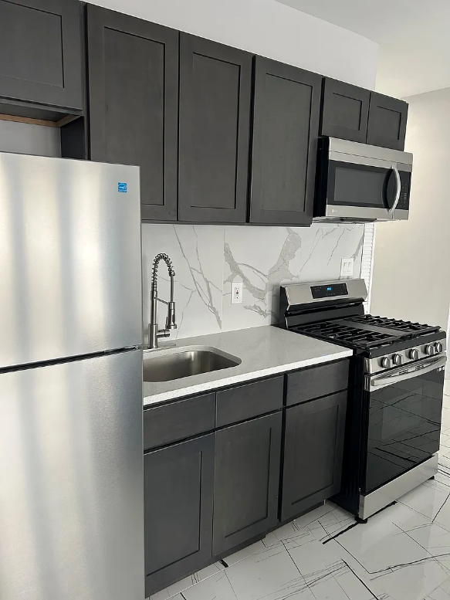 | Leasing Agent  Management company  (973) 604-8790  Custom apartment renovations  610 Salem is a Pre-War building in the heart of Elizabeth NJ with new upgrades and custom apartment renovations!  Facts, features & policies  Building amenities  Services & facilities  24 hour maintenance  Online maintenance portal  View description  City  Policies  Lease terms  One year  Pets  Large dogs  Not allowed  Small dogs  Allowed  Cats  Allowed  Utilities included in rent  Garbage  Sewer  Water  Heat  Hot water  Unit features  Appliances  Dishwasher  Dryer  Microwave oven  Oven  Range  Refrigerator  Washer  Cooling  Air conditioning: Window  Flooring  Hardwood  Laminate  Tile  Heating  Electric  Special features  Brand new countertops
Cambridge Manor  539 N Broad St, Elizabeth, NJ 07208 | $1,520+  Studio  $1,850  1 bd  $2,000+ | NOW | 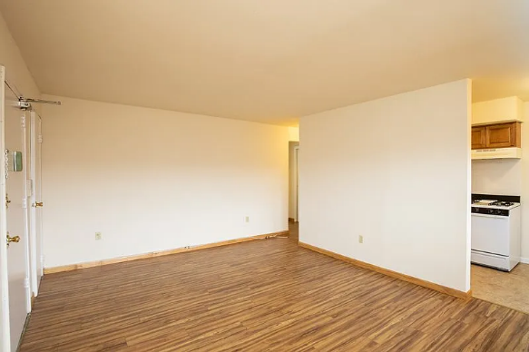 | Special offer!  All Unit Types may not be available immediately, please contact our Leasing Office for latest availability  Current Office Hours: Mon-Fri 9-4PM, Closed Sat-Sun  Our spacious apartments provide the perfect space for a home office or children's play area.  Apartment building  Studio-2 beds  Pet-friendly  Air conditioning available  Contact manager for more details about this building.  Services & facilities  24 hour maintenance  Policies  Pets  Cats  Allowed  2 pet max  1 Pet: $350 Fee/$35 Monthly Fee, 2 Pets: $500 Fee/$50 Monthly Fee  2 pet max per household  Dogs  Allowed  2 pet max  1 Pet: $350 Fee/$35 Monthly Fee, 2 Pets: $500 Fee/$50 Monthly Fee  Breed restrictions apply  2 pet max per household  Unit features  Appliances  Freezer  Oven  Range  Refrigerator  Cooling  Air conditioning  Flooring  Carpet  Hardwood  Heating  Gas  Special features  Eat-In Kitchen  New/Renovated Interiors  Security Lighting  Walk In Closets (select units)
POSSIBLE ROOMS FOR RENT IN NEWARK NJ
69 Columbia St. Newark  ' | 201-591-1100 Ext 216 | Ashley
79 Columbia St. Newark | 201-591-1100 Ext 216 | Ashley
83 Green St. Newark | •  201-591-1100 Ext 216 | Ashley
168 Clinton Ave. Newark | 201-591-1100 Ext 216 - | Ashley
69-77 Pennsylvania Ave Nwk | 201-591-1100 Ext 216 | Ashley
1163 Court St. Newark | 201-591-1100 Ext 216  ' . | "  Ashley
468 Washington St .Newark | 201-591-1100 Ext 216 | Ashley
471 Washington St .Newark | 201-591-1100 Ext 216 | Ashley  ..
472 Washington St. Newark | 201-591-1100 Ext 216 | Ashley  ..
474 Washington St. Newark | 201-591-1100 Ext 216 | Ashley
476 Washington St. Newark | 201-591-1100 Ext 216 | Ashley
667 Clinton Ave. Newark | 201-591-1100 Ext 216 | Ashley
75 Baldwin St. Newark | 201-591-1100 Ext 216 | Ashley
52 S. Walnut St East Orange | 201-591-1100 Ext 216 | Ashley
70 Chestnut St East Orange | 201-591-1100 Ext 216 | Ashley
811 Bergen St. Newark | 954-675-5359 | Mattv Green
31 South Street Newark | 732-382-2067 | Lucy
66 Sherman Ave.. . Newark | 201-591-1100 Ext 216 | Ashley
1182 Elizabeth Ave. Elizabeth NJ | 973-624-3300 | Jim Cooper
1'123 Magnolia Ave. Elizabeth NJ | 973-624-3300 | Jim Cooper
1039 Mitgnolia Ave. Elizabeth NJ | 973-624-3300 | Jim Cooper  ,.

